**Final Assignment: Part 2 - Create Dashboard with Plotly and Dash**

This file only contains the images from Dash uploaded for the final exam.

*Submitted by Kailani Bailey on June 1, 2024*

**Task 1.1**

**Develop a Line Plot using the functionality of Pandas to show how automobile sales fluctuate from year to year.**

Submit the image *Line_Plot_1.png*

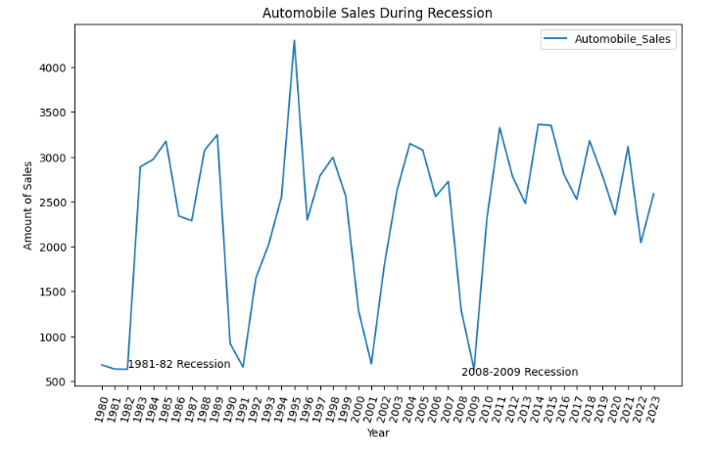

**Task 1.2**

**Plot different lines for categories of vehicle type and analyze the trend to answer the question, “Is there noticeable difference in sales trends between different vehicle types during recession periods?”**

Submit the image *Line_Plot_2.png*

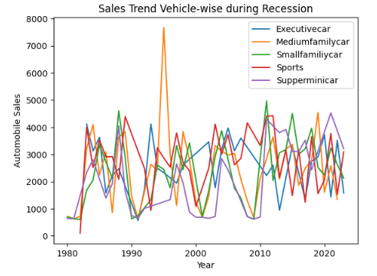

**Task 1.3**

**Use the functionality of Seaborn Library to create a visualization to compare the sales trend per vehicle type for a recession period with a non-recession period.**

Submit the image *Bar_Chart.png*

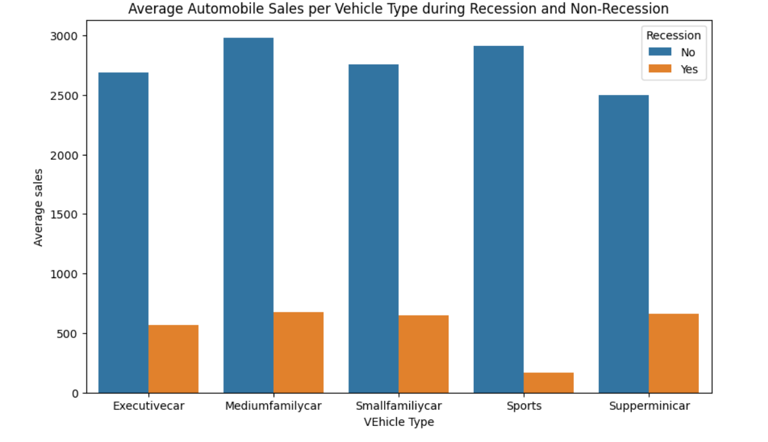

**Task 1.4**

**Use subplotting to compare the variations of GDP during recession and non-recession period by developing line plots for each period.**

Submit the image *Subplot.png*

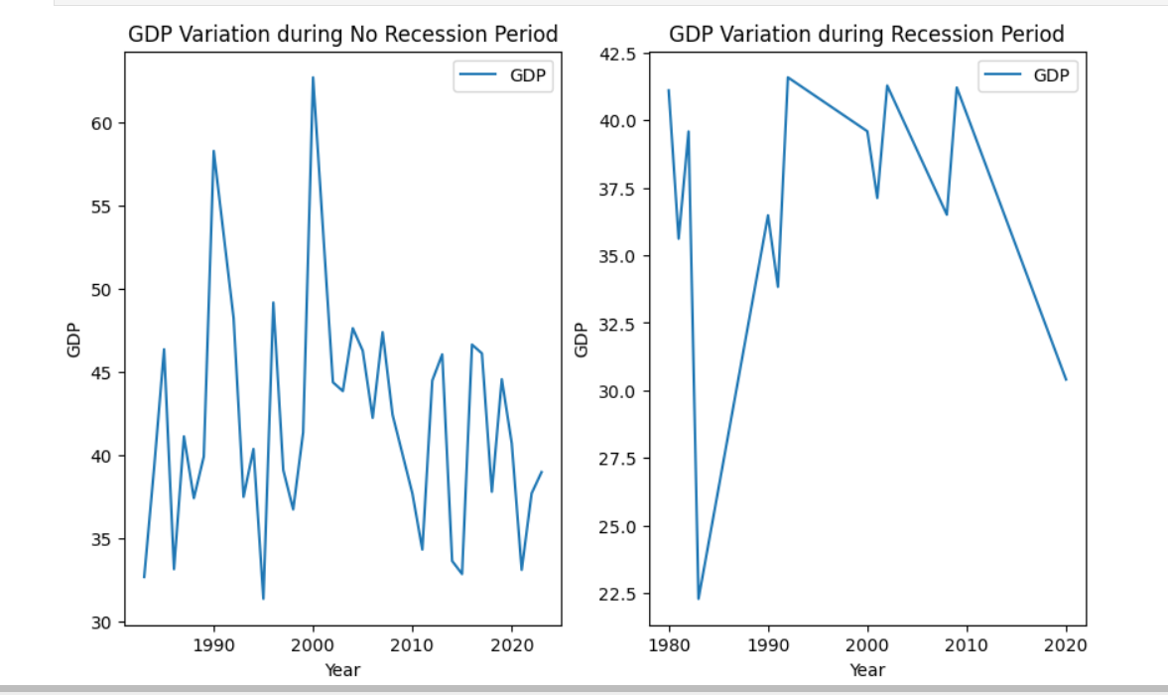

**Task 1.5**

**Develop a Bubble Plot for displaying the impact of seasonality on Automobile Sales.**

Submit the image *Bubble.png*

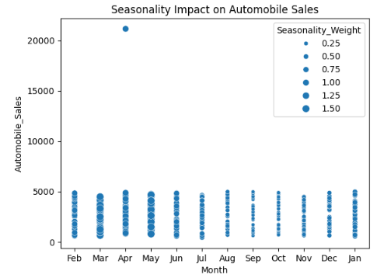

**Task 1.6**

**Use the functionality of Matplotlib to develop a Scatter Plot to identify the correlation between average vehicle price related to the sales volume during recessions.**

Submit the image *Scatter.png*

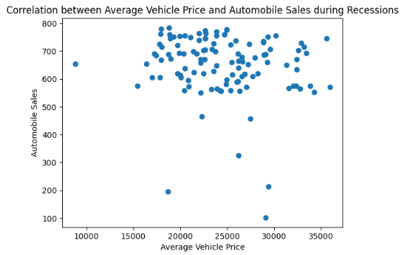

**Task 1.7**

**Create a Pie Chart to display the portion of advertising expenditure of XYZAutomotives during recession and non-recession periods.**

Submit the image *Pie_1.png*

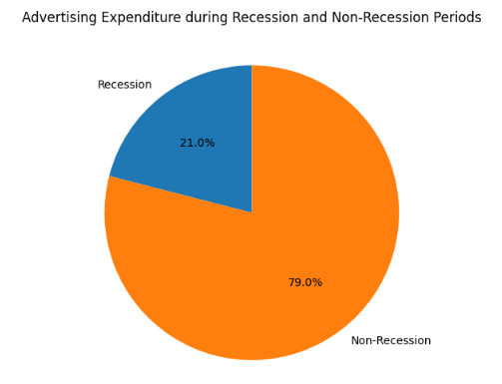

**Task 1.8**

**Develop a Pie Chart to display the total advertising expenditure for each vehicle type during recession period.**

Submit the image *Pie_2.png*

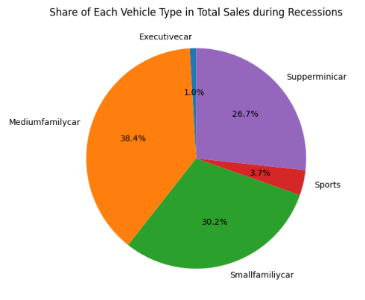

**Task 1.9**

**Develop a Line Plot to analyze the effect of the unemployment rate on vehicle type and sales during the recession period.**

Submit image *Line_Plot_3.png*

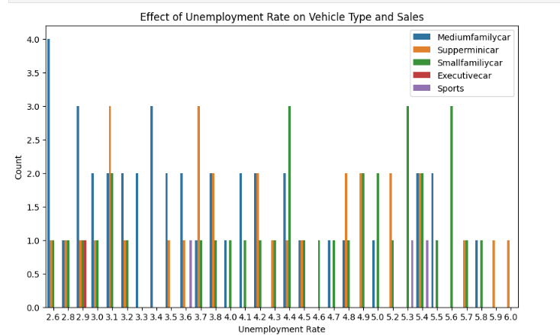

**Task 2.1**

**Create a Dash application and give it a meaningful title.**

Submit the image *Title.png*



**Task 2.2**

**Add drop-downs to your dashboard with appropriate titles and options.**

Submit the image *Dropdown.png*

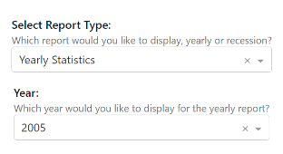

**Task 2.3**

**Add a division for output display with appropriate ‘id’ and ‘classname’ properties.**

Submit the image *Outputdiv.png*

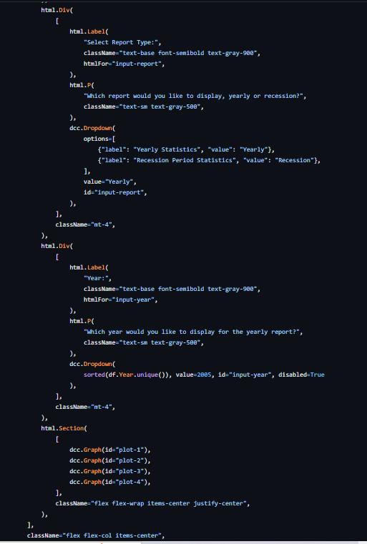

**Task 2.4**

**Creating Callbacks: Define the callback function to update the input container based on the selected statistics and the output container.**

Submit the *Callbacks.png*

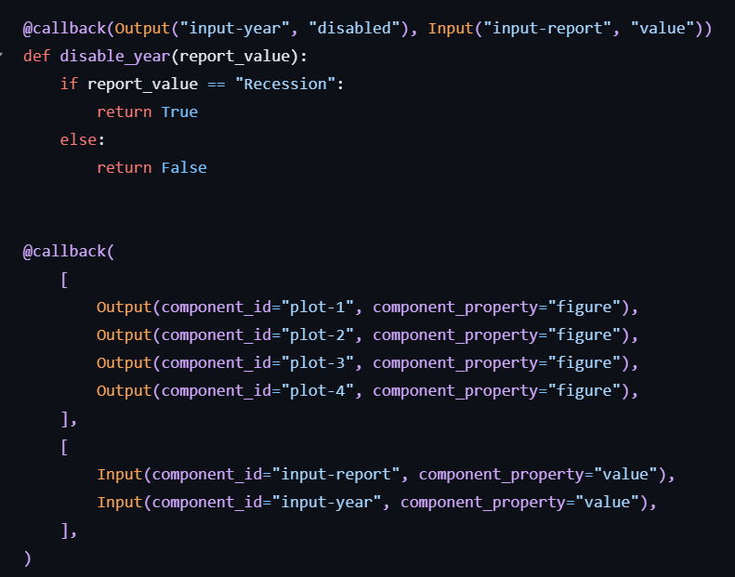

**Task 2.5**

**Create and display graphs for Recession Report Statistics.**

Submit the image *RecessionReportGraphs.png*

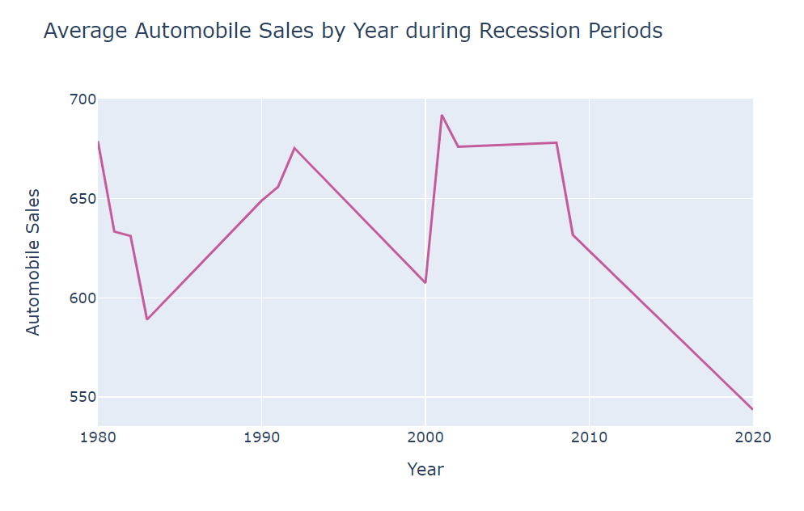

**Task 2.6**

**Create and display graphs for Yearly Report Statistics.**

Submit the image *YearlyReportGraphs.png* for the report types.

